**python=3.11.11**

**### Install the following package in anaconda cmd**

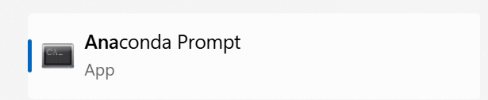

**## Install energyplus-core:**

pip install --extra-index-url <https://github.com/SGHVAIC/EnergyPlus-Core-Python>

python -m pip install --extra-index-url https://test.pypi.org/simple energyplus-core

**## Install requirement4.txt**

pip install -r requirements4.txt

**## Install requirement3.txt**

pip install -r requirements3.txt

**## Install other package:**

pip install gymnasium

pip install stable_baselines3

pip install tyro

pip install tensorboard

pip install ray

**## not need if no tree and dm-tree install**

pip uninstall tree

pip uninstall dm-tree

pip install --upgrade ray

**#### Here we do not install tree but only dm-tree**

pip install dm-tree

**## Install wandb and configure for your own account, Click** [**here**](https://docs.wandb.ai/quickstart/) **for guidance**

pip install wandb

pip install tqdm

pip install scipy

pip install ray[tune]